Create an Account with Twitch

DESKTOP SIGNUP

To sign up for an account, go to https://www.twitch.tv and select the Sign up button on the top-right portion of the page.

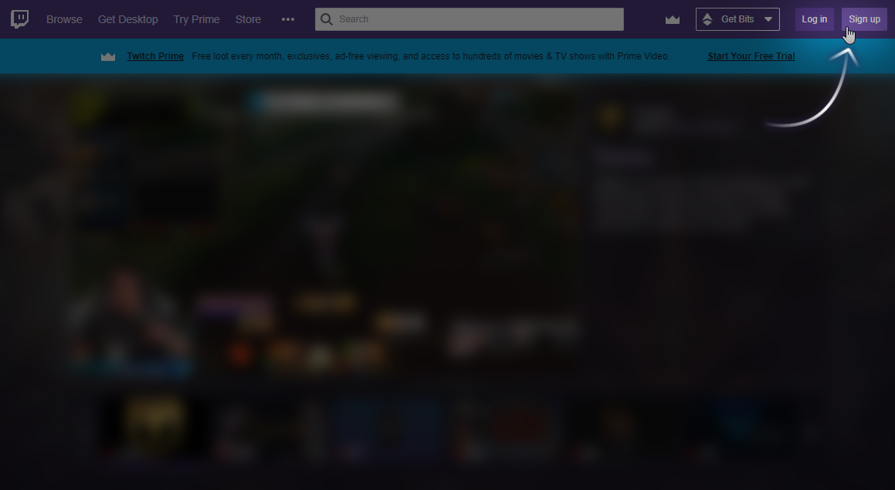

This will open the Log In / Sign Up screen. To sign up for a new account on Twitch, fill out the Sign Up form. Choose a username (between 4-25 characters in length), set your password, email and date of birth.

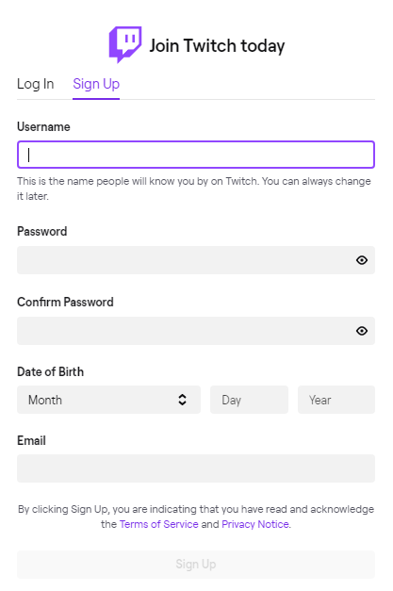
MOBILE SIGNUP

To sign up for an account on mobile, download the Twitch Mobile App for your device. Once downloaded and installed, launch the app on your device and tap the Sign Up button.

When signing up for an account on mobile you will be able to sign up using your mobile phone number (landline or VOIP phone numbers will not be accepted) or email address.

Your phone may provide a quick fill option for your phone number during sign up which you can use to quickly enter your phone number. If you wish to use email instead, tap the Use email instead option above the quick fill.
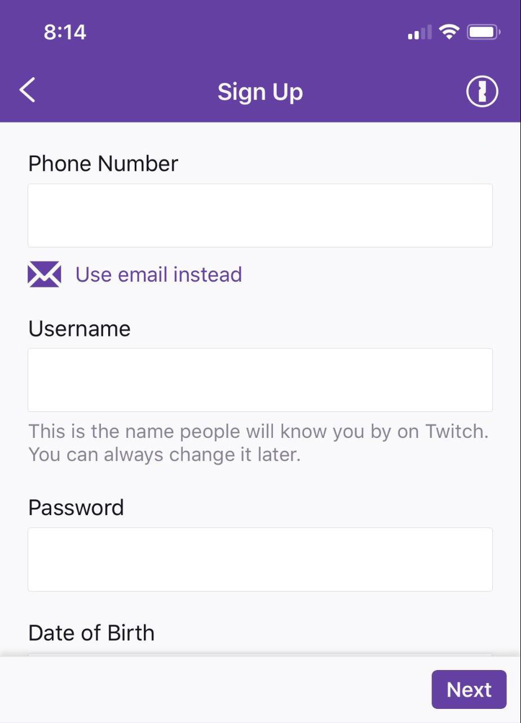

Please note that SMS and data rates may apply.

Once you’ve completed the Sign Up form, click the Sign Up button at the bottom. Twitch will then attempt to confirm the phone number or email address you provided by sending a 6 digit code known as a one-time password (OTP) via SMS or email. If you signed up using a phone number, some devices may autofill the code automatically once you receive the SMS. If your phone does not support this you will need to retrieve the 6 digit code from your SMS or email and enter it on the app within 5 minutes.

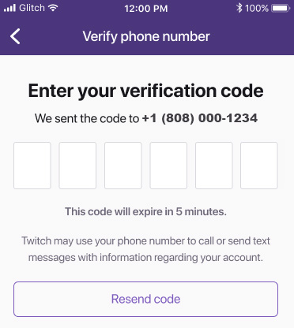
If you do not receive a text or email within 5 minutes, tap the arrow in the top left to go back and double check the phone number or email address provided is correct and then retry.

Event Link:

https://www.twitch.tv/jayblackcomedian

